Task 3: Login System with Validation
Aim: To design and develop a login system that validates user inputs using JavaScript, verifies user credentials from a database, and displays appropriate error messages dynamically.
Algorithm:
- Start the program
- Display the login form
- Enter username and password
- Validate input using JavaScript (check empty fields)
- Send data to server (PHP)
- Connect to database
- Check credentials using SQL query
- If valid → show login success
- Else → show error message
- Stop the program
Program:
Login.html:
<!DOCTYPE html>
<html>
<head>
<title>Login</title>
<style>
body { font-family: Arial; background: #f2f2f2; }
.box {
width: 300px;
margin: 100px auto;
background: white;
padding: 20px;
}
input {
width: 100%;
padding: 10px;
margin: 8px 0;
}
button {
width: 100%;
padding: 10px;
background: green;
color: white;
border: none;
}
.error { color: red; }
</style>
<script>
function validateForm() {
let u = document.forms["f"]["username"].value;
let p = document.forms["f"]["password"].value;
if (u == "" || p == "") {
document.getElementById("error").innerHTML = "All fields required!";
return false;
}
if (p.length < 4) {
document.getElementById("error").innerHTML = "Password too short!";
return false;
}
return true;
}
</script>
</head>
<body>
<div class="box">
<h2>Login</h2>
<form name="f" action="login.php" method="POST" onsubmit="return validateForm()">
<input type="text" name="username" placeholder="Username">
<input type="password" name="password" placeholder="Password">
<div id="error" class="error"></div>
<button type="submit">Login</button>
</form>
</div>
</body>
</html>
Login.php:
<?php
include 'db.php';
$username = $_POST['username'];
$password = $_POST['password'];
$sql = "SELECT * FROM users WHERE username='$username' AND password='$password'";
$result = $conn->query($sql);
if ($result->num_rows > 0) {
header("Location: home.php");
} else {
echo "<h3 style='color:red;'>Invalid Username or Password</h3>";
echo "<a href='login.html'>Try Again</a>";
}
$conn->close();
?>

Home.php:
<!DOCTYPE html>
<html>
<head>
<title>Home</title>
</head>
<body>
<h2>Welcome! Login Successful 🎉</h2>
<a href="login.html">Logout</a>
</body>
</html>
Database:
CREATE DATABASE student_db;
USE student_db;
CREATE TABLE users (
id INT AUTO_INCREMENT PRIMARY KEY,
username VARCHAR(50),
password VARCHAR(50)
);
INSERT INTO users (username, password) VALUES
('admin', '1234'),
('user1', 'pass123');

Output:
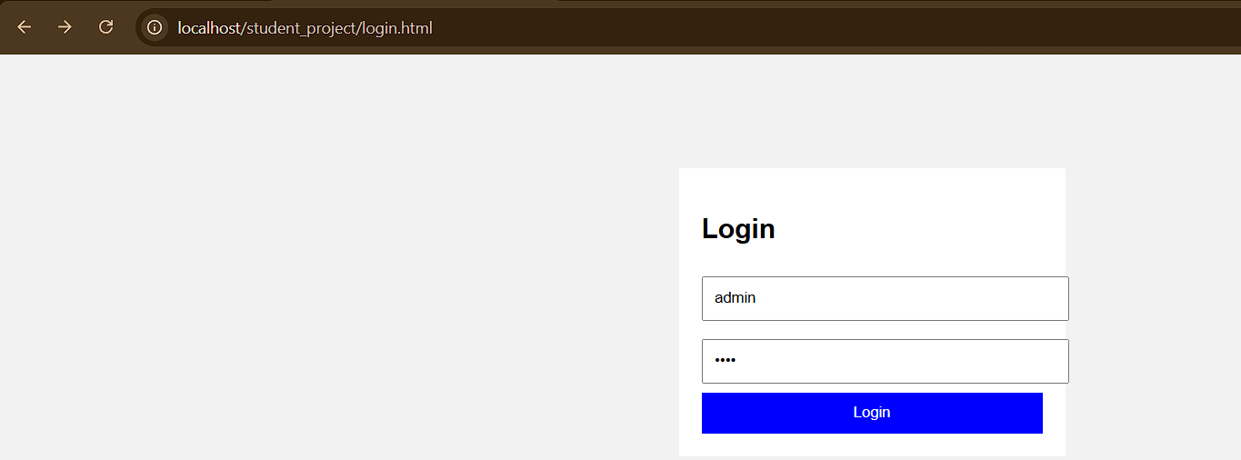

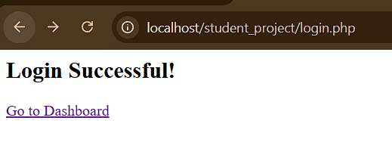

Result: Thus, the login page and the connection to the dashboard has been successfully executed and output generated.

